1. **INTRODUCTION**
   1. **OVERVIEW**

A project focused on the exploration of Apple's iPhone impact in India would involve various aspects, including market analysis, socio-economic effects, and technological implications. Here's an overview of what the project might convey. Analyze iPhone sales trends and market share in India. Study the influence of iPhones on consumer behavior and lifestyle. Investigate the innovation and technological advancements driven by Apple in India. Assess the environmental impact of iPhone production, usage, and disposal in India.

* 1. **PURPOSE**

The purpose of a project exploring Apple's iPhone impact in India can be multifaceted, aiming to achieve several objectives. To gain insights into how Apple's iPhones have impacted the Indian smartphone market, including market share, sales trends, and consumer preferences. To assess the economic ramifications, such as job creation, investment, and contributions to the Indian economy, resulting from Apple's presence in India. To explore the societal and cultural changes brought about by the widespread use of iPhones, including changes in lifestyle, communication, and consumer behavior.

1. **PROBLEM DEFINITION AND DESIGNING THINKING**
   1. **EMPATHY** **MAP**

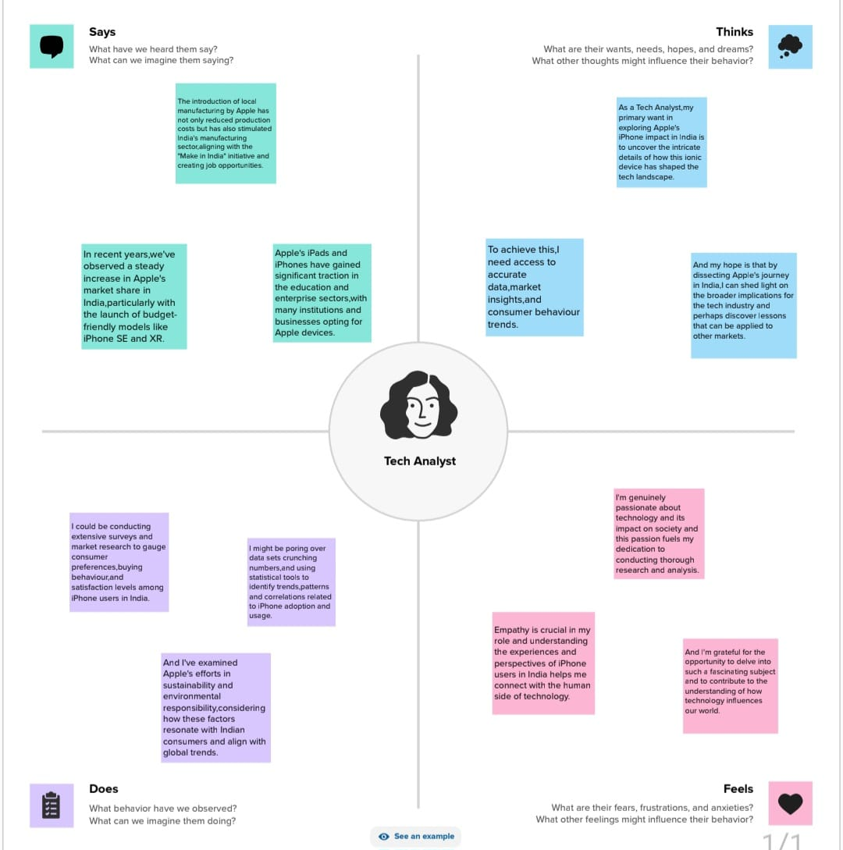

* 1. **IDEATION AND BRAIN STORMING MAP**

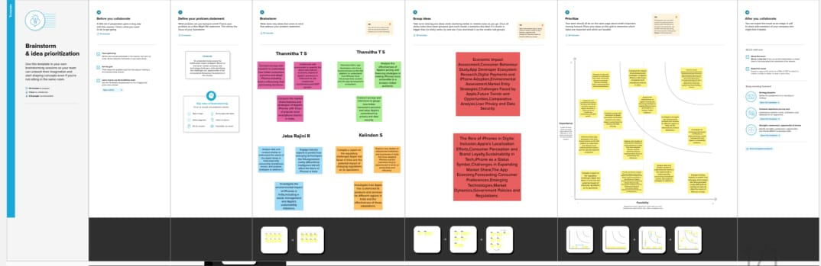

1. **RESULT**
   1. **DASHBOARD 1**

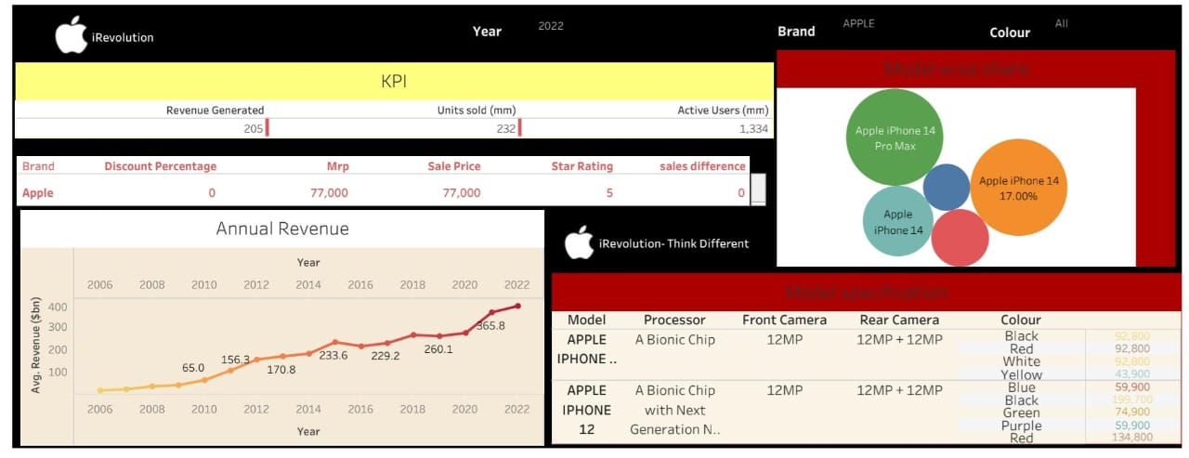

* 1. **DASHBOARD 2**

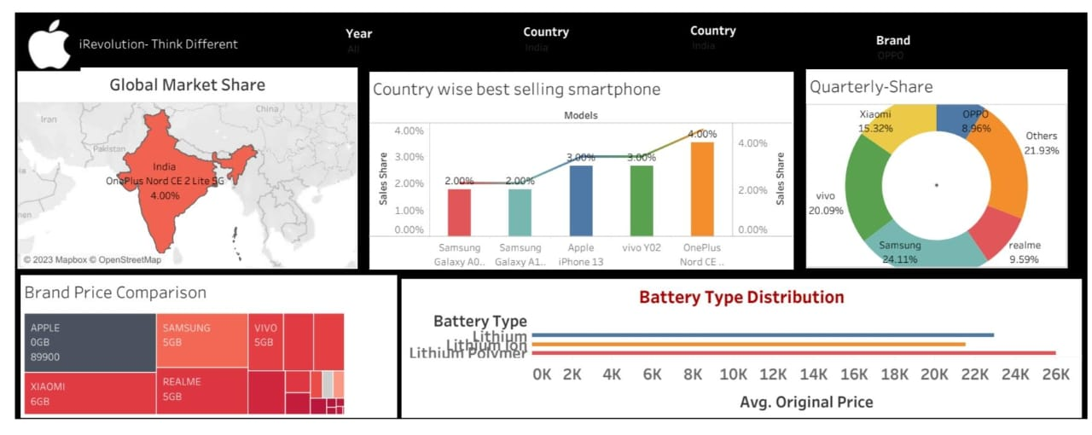

* 1. **STORY 1**

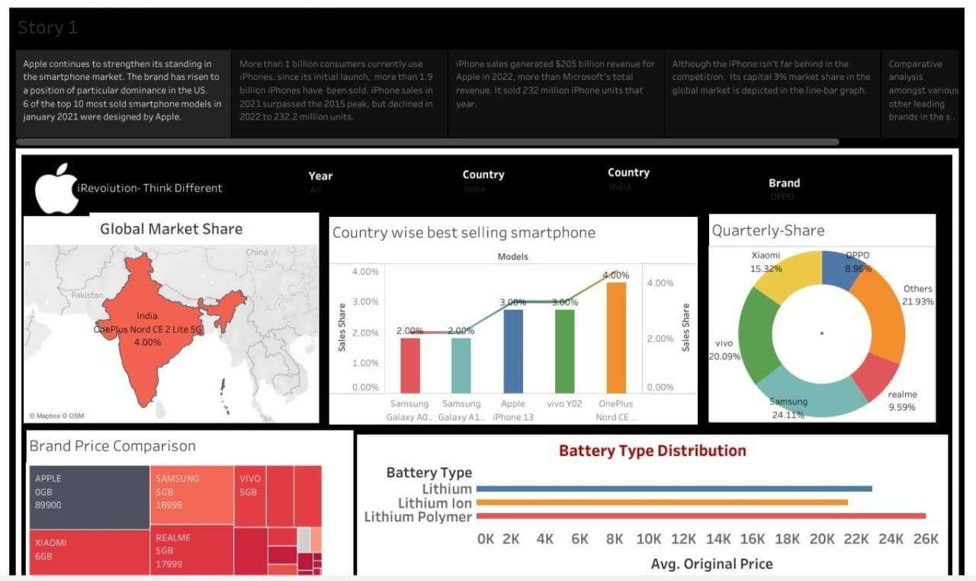

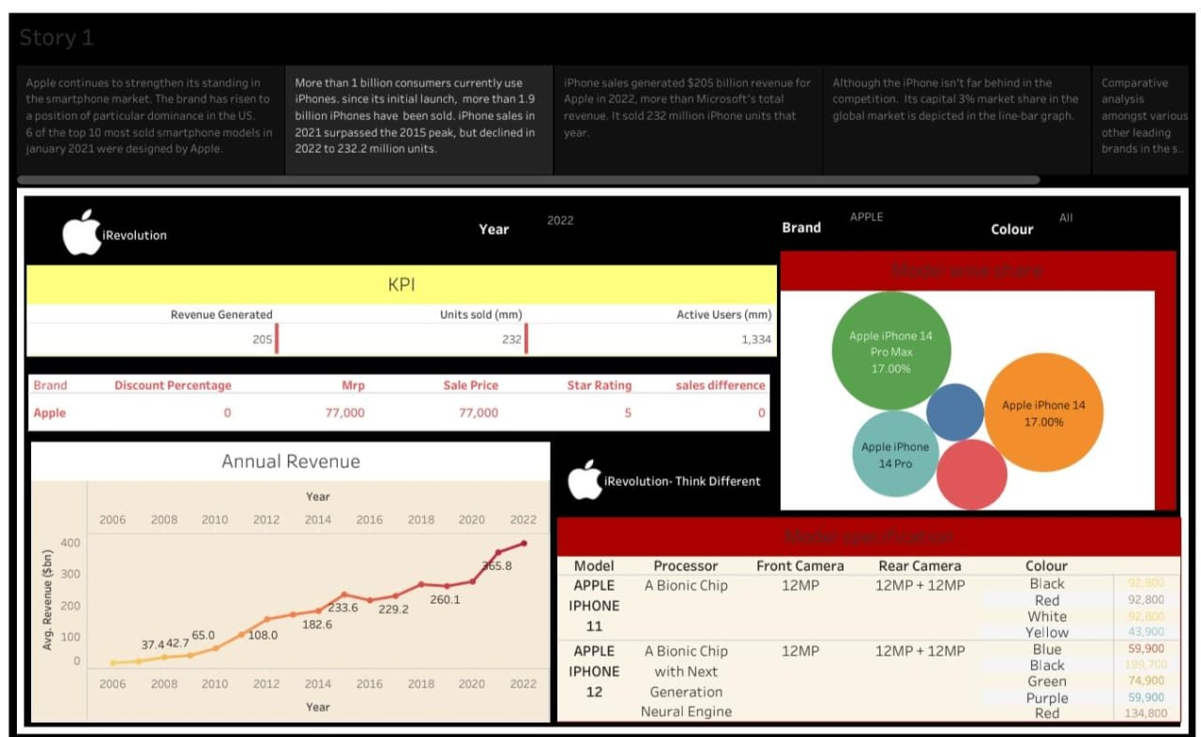

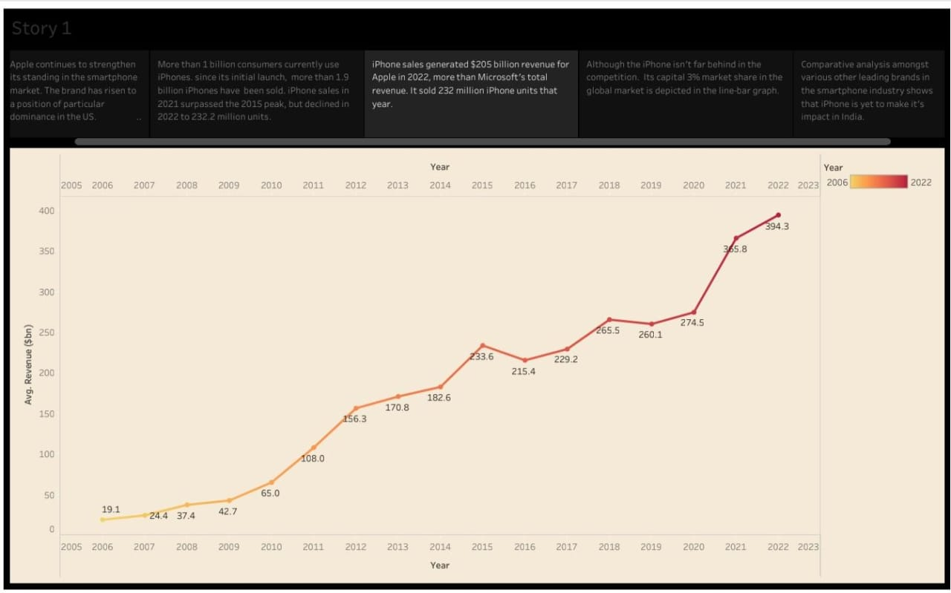

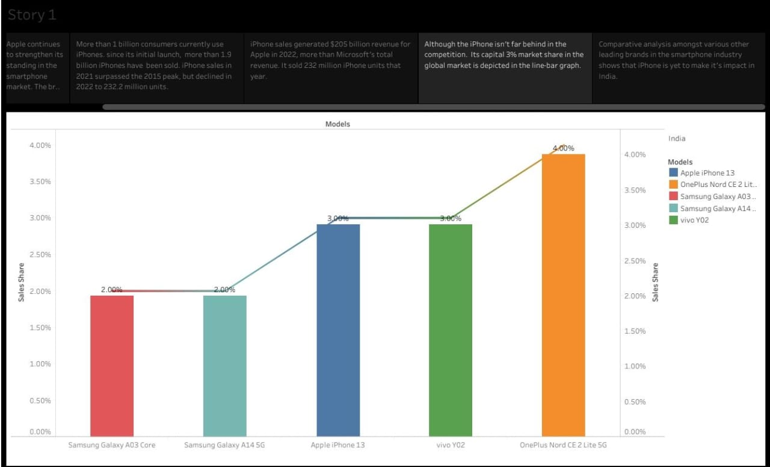

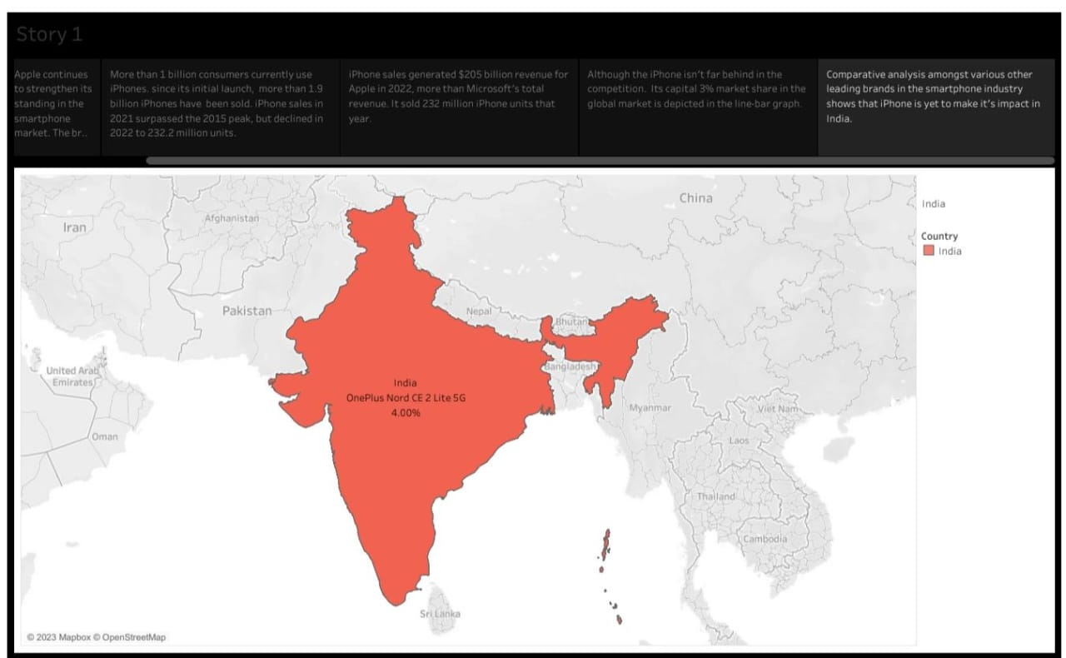

1. **ADVANTAGES AND DISADVANTAGES** 
   1. **ADVANTAGES**

* **Informed Decision-Making: Provides valuable insights for Apple, policymakers, and businesses operating in India to make informed decisions about their strategies and policies.**
* **Economic Insights: Helps to understand the economic impact, potentially leading to job creation and investment, which is beneficial for India's economy.**
* **Consumer Awareness: Raises awareness among Indian consumers about the impact of iPhone usage and its potential influence on their lives.**
* **Technological Advancements: Identifies technological advancements and innovation, promoting growth in the tech sector.**
* **Environmental Awareness: Draws attention to environmental implications, encouraging sustainable practices in production and usage.**
  1. **DISADVANTAGES**
* **Resource-Intensive: Conducting such a comprehensive study can be resource-intensive in terms of time, money, and manpower.**
* **Complexity: The project involves analyzing multiple dimensions, which can be complex and challenging to manage.**
* **Subjectivity: Findings can be subject to interpretation, and bias in data collection or analysis may skew results.**
* **Potential for Controversy: The project might unearth findings that could be controversial or politically sensitive.**
* **Data Privacy: Collecting data about iPhone users may raise concerns about data privacy and ethics.**

1. **APPLICATIONS**

**Solutions for conducting the project "Driven exploration of Apple's iPhone impact in India" effectively include:**

**Defining clear and specific research objectives to guide the project, ensuring that it addresses the key aspects of Apple's iPhone impact in India.** **Assemble an interdisciplinary team with expertise in market research, economics, technology, sociology, and environmental science to cover all project dimensions.**

**Develop a robust research methodology that includes surveys, interviews, data analysis, and environmental assessments, ensuring the reliability and validity of findings.** **Implement stringent data privacy measures and ethical considerations to protect the personal information of respondents.** **Collect data from a diverse sample of iPhone users, local businesses, and industry experts to ensure comprehensive insights.**

1. **CONCLUSION**

**In conclusion, the "Driven exploration of Apple's iPhone impact in India" project has provided valuable insights into the multifaceted effects of Apple's iPhones on the Indian market, economy, society, and environment. The project has yielded a deeper understanding of the following key areas:**

**Apple's iPhones have significantly influenced the Indian smartphone market, with notable market share and a distinct impact on consumer preferences.** **The presence of Apple in India has contributed to economic growth, including job creation, investment, and local manufacturing. iPhones have brought about changes in consumer behavior, lifestyle, and social interactions in India, influencing popular culture and communication patterns.**

**The introduction of iPhones has spurred technological advancements, especially in the app development sector, fostering innovation and growth in the Indian tech industry. The project has highlighted environmental concerns, prompting discussions on sustainable production and responsible disposal practices.**

1. **FUTURE SCOPES**

**The project "Driven exploration of Apple's iPhone impact in India" offers several future scopes and opportunities for further research and exploration: Continuing the project as a longitudinal study to track changes over time will provide insights into the evolving impact of iPhones on India's market, society, and environment. Expanding the research to compare the impact of iPhones with other smartphone brands and models will allow for a more comprehensive understanding of the Indian smartphone market. Focusing on specific regions within India to understand how the impact of iPhones varies across demographics areas.**